FB02 -

Functionality
Sometimes you need to change an already posted document. Typical examples are fields like Text (a document description) or Assignment. Of course you cannot change the line items amounts! For this you need to post a reversal.

Scenario
Certain transactions, especially from logistics, lack certain information. We need to add more information. You need to add more information to the automatically created financial documents, e.g. Text field, via document change.

Requirements
A posted document.

Menu Path | Accounting → Financial Accounting → General Ledger → Document → FB02 – Change
Transaction Code | FB02

1. Double click on FB02 – Change

Change Document: Initial Screen

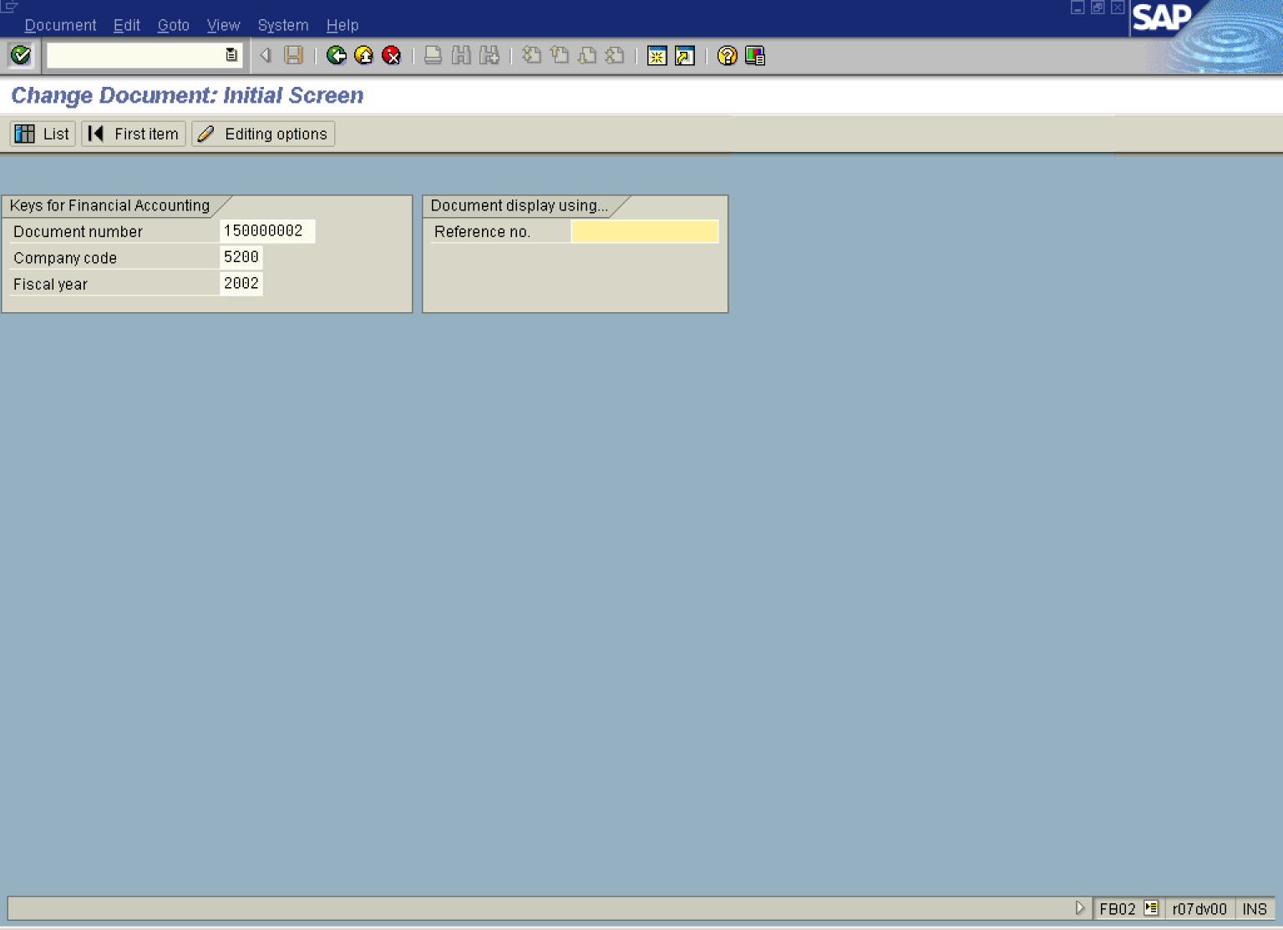

2. Update the following fields:

Field Name | Field Description | Values
Document number | Enter here a number of the document you want to change | Example: 150000002
Company code | Code identifying a separate legal entity for which a separate set of accounts is maintained for external reporting purposes | Example: 5200
Fiscal year | Number of the fiscal year | Example: 2002

Tip: If you don't know the document number, click List button. The system will display a search screen. Enter the required criteria and search for the document you want to change.

3. Click Enter Button . The system will display a document overview:

Change Document: Overview

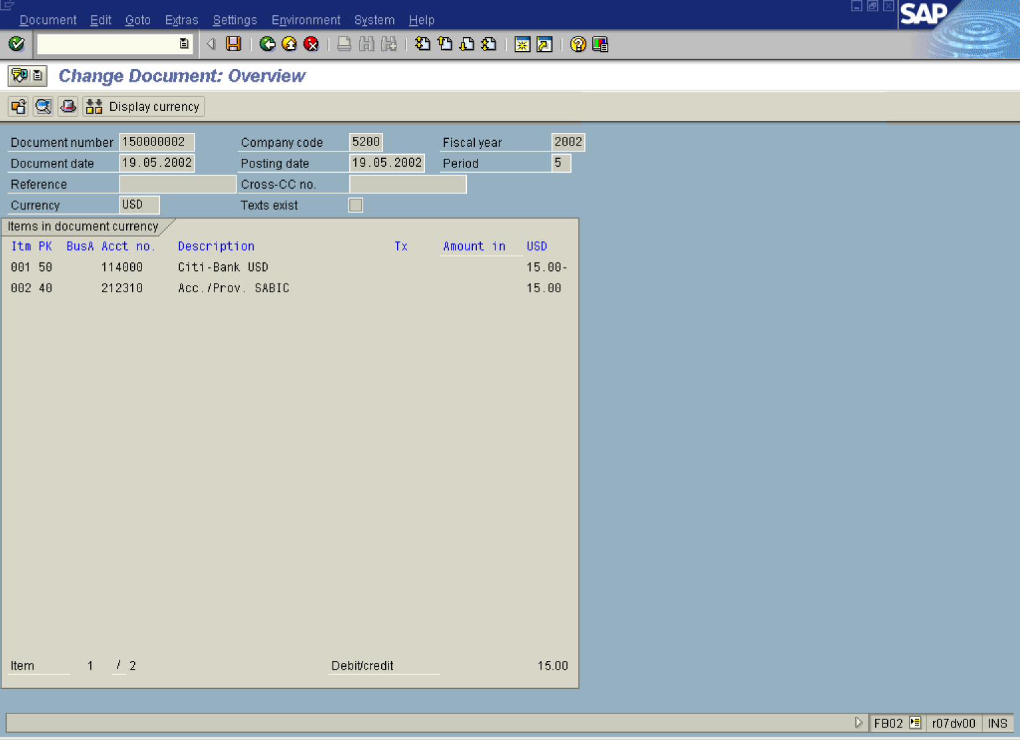

4. To change a line item, simply double click on it:

Change Document: Line Item 001

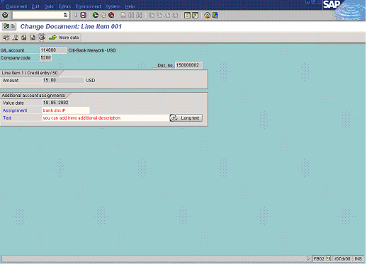

5. The fields you can change are displayed in red. You can change the contents of the following fields:

Field Name | Field Description | Values
Assignment | The assignment number is an additional information reference. | Example: bank doc #
Text | Additional document description | Example: you can add here additional description

6. On the same screen you can change also some fields in the doc. header. Click Document Header Button .

Document Header: 5200 Company Code

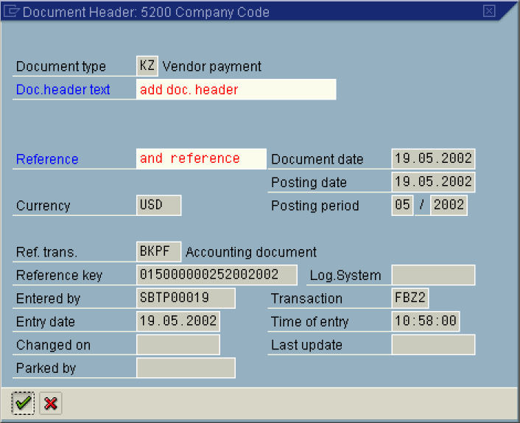

7. Update the following fields:

Field Name | Field Description | Values
Doc.header text | Explanation or note that applies to the document | Example: add doc. header
Reference | Explanation or note that applies to the document | Example: and reference

8. Click Enter Button to confirm your entries.

9. Click Next Line Button to switch to the next line item. Here you can also apply some changes:

Change Document: Line Item 002

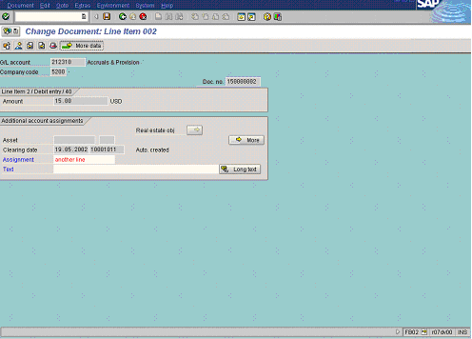

10. Update the following fields:

Field Name | Field Description | Values
Assignment | Note that applies to the document | Example: another line

11. Click Enter.

12. To store your changes in the document, click Save .

13. The message bar displays “Changes have been saved”.

